**Project Name: Ride Sharing Management System**

**Course Teacher: Kawser Irom Rushee**

**Group Members**

|  |  |
| --- | --- |
| Name | ID |
| Shovon Roy | 19-40023-1 |
| Subrata Das | 19-40015-1 |
| Barshan Ghosh | 19-41305-3 |
| Sharanya Das | 19-41299-3 |

**Scenario**

**A registered user sends a request to hire a car for a ride. A user has name, email, location, an unique id and so on. The request goes to Trip where it has attributes such as pick up and drop off location, trip distance and an unique trip id. The trip is handled by the company and the company chooses all the nearby drivers and then the driver chooses the following trip details. A driver has an unique attribute driver license. Finally after completing the trip the user pays the driver.**

**ER Diagram**

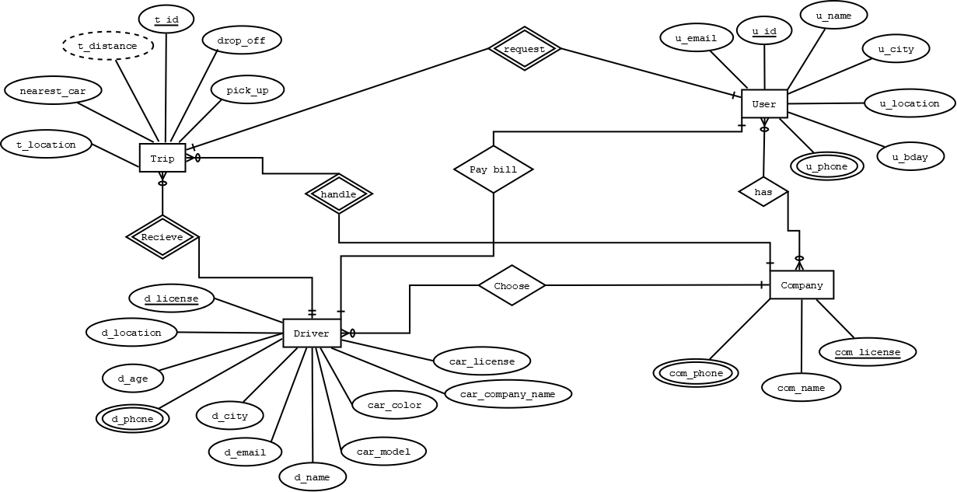

**Normalization**

UNF: (User & Company)

u_id, u_name, u_bday, u_email, u_phone, u_location, u_city, com_license, com_name, com_phone

1NF: (User & Company)

u_id, u_name, u_bday, u_email, u_phone, u_location, u_city, com_license, com_name, com_phone

2NF: (User & Company)

T1: u_id, u_name, u_bday, u_email, u_phone, u_location, u_city, com_license

T2: com_license, com_name, com_phone

3NF: (User & Company)

T1: u_id, u_name, u_bday, u_email, u_phone, u_city, com_license

T2: u_city, u_location

T3: com_license, com_name, com_phone

UNF: (User & Trip)

u_id, u_name, u_bday, u_email, u_phone, u_location, u_city, t_id, pick_up, drop_off, t_distance, t_location, nearest_car

1NF: (User & Trip)

u_id, u_name, u_bday, u_email, u_phone, u_location, u_city, t_id, pick_up, drop_off, t_distance, t_location, nearest_car

2NF: (User & Trip)

T1: u_id, u_name, u_bday, u_email, u_phone, u_location, u_city, t_id

T2: t_id, pick_up, drop_off, t_distance, t_location, nearest_car

3NF: (User & Trip)

T1: u_id, u_name, u_bday, u_email, u_phone, u_city, t_id

T2: u_city, u_location

T3: t_id, pick_up, drop_off, t_distance, t_location

T4: t_location, nearest_car

UNF: (Driver & Company)

d_license, d_name, d_email, d_phone, d_location, d_age, d_city, car_license, car_color, car_company_name, car_model, com_license, com_name, com_phone

1NF: (Driver & Company)

d_license, d_name, d_email, d_phone, d_location, d_age, d_city, car_license, car_color, car_company_name, car_model, com_license, com_name, com_phone

2NF: (Driver & Company)

T1: d_license, d_name, d_email, d_phone, d_location, d_age, d_city, car_license, car_color, car_company_name, car_model, com_license

T2: com_license , com_name, com_phone

3NF: (Driver & Company)

T1: d_license, d_name, d_email, d_phone, d_age, d_city, car_license, car_color, car_company_name, com_license

T2: d_city, d_location

T3: car_company_name, car_model

T4: com_license, com_name, com-phone

UNF: (Company & Trip)

com_license, com_name, com_phone, t_id, pick_up, drop_off, t_distance, t_location, nearest_car

1NF: (Company & Trip)

com_license, com_name, com_phone, t_id, pick_up, drop_off, t_distance, t_location, nearest_car

2NF: (Company & Trip)

T1: com_license, com_name, com_phone, t_id

T2: t_id, pick_up, drop_off, t_distance, t_location, nearest_car

3NF: (Company & Trip)

T1: com_license, com_name, com_phone, t_id

T2: t_id, pick_up, drop_off, t_distance, t_location

T3: t_location, nearest_car

UNF: (User & Driver)

u_id, u_name, u_bday, u_email, u_phone, u_location, u_city, d_license, d_name, d_email, d_phone, d_location, d_age, d_city, car_license, car_color, car_company_name, car_model

1NF: (User & Driver)

u.id, u.name, u.bday, u.email, u.phone, u.location, u.city, d.license, d.name, d.email, d.phone, d.location, d.age, d.city, car.license, car.color, car.company.name, car.model

2NF: (User & Driver)

T1: u_id, u_name, u_bday, u_email, u_phone, u_location, d_age, u_city, d_license

T2: d_license, d_name, d_email, d_phone, d_location, d_city, car_license, car_color, car_company_name, car_model

3NF: (User & Driver)

T1: u_id, u_name, u_bday, u_email, u_phone, u_city, d_license

T2: u_city, u_location

T3: d_license, d_name, d_email, d_phone, d_location, d_age, d_city, car_license, car_color, car_company_name

T4: d_city, d_location

T5: car_company_name, car_model

UNF: (Driver & Trip)

d_license, d_name, d_email, d_phone, d_location, d_age, d_city, car_license, car_color, car_company_name, car_model, t_id, pick_up, drop_off, t_distance, t_location, nearest_car

1NF: (Driver & Trip)

d_license, d_name, d_email, d_phone, d_location, d_age, d_city, car_license, car_color, car_company_name, car_model, t_id, pick_up, drop_off, t_distance, t_location, nearest_car

2NF: (Driver & Trip)

T1: d_license, d_name, d_email, d_phone, d_location, d_age, d_city, car_license, car_color, car_company_name, car_model, t_id

T2: t_id, pick_up, drop_off, t_distance, t_location, nearest_car

3NF: (Driver & Trip)

T1: d_license, d_name, d_email, d_phone, d_age, d_city, car_license, car_color, car_company_name, t_id

T2: d_city, d_location

T3: car_company_name, car_model

T4: t_id, pick_up, drop_off, t_distance, t_location

T5: t_location, nearest_car

**Table**

|  |  |  |  |
| --- | --- | --- | --- |
| **No.** | **Table Name** | **Attribute** | **Constraint** |
| 1 | RS_user | u_id u_name, u_bday, u_email, u_phone, u_city, com_license |  |
| 2 | User_Location | u_city, u_location |  |
| 3 | User_Driver_Rel | u_id, u_name, u_bday, u_email, u_phone, u_city, d_license |  |
| 4 | User_Trip_Rel | u_id, u_name, u_bday, u_email, u_phone, u_city, t_id |  |
| 5 | RS_driver | d_license, d_name, d_email, d_phone, d_age, d_city, car_license, car_color, car_company_name, com_license | CONSTRAINT cr_driver |
| 6 | Driver_Location | d_city, d_location |  |
| 7 | Driver_Trip_Rel | d_license, d_name, d_email, d_phone, d_age, d_city, car_license, car_color, car_company_name, t_id |  |
| 8 | Car_Details | car_company_name, car_model |  |
| 9 | RS_company | com_license, com_name, com_phone, t_id |  |
| 10 | RS_trip | t_id, pick_up, drop_off, t_distance, t_location |  |
| 11 | TripLocation_Cars | t_location, nearest_car |  |

**Table Creation with Inserted Values**

**RS_User**

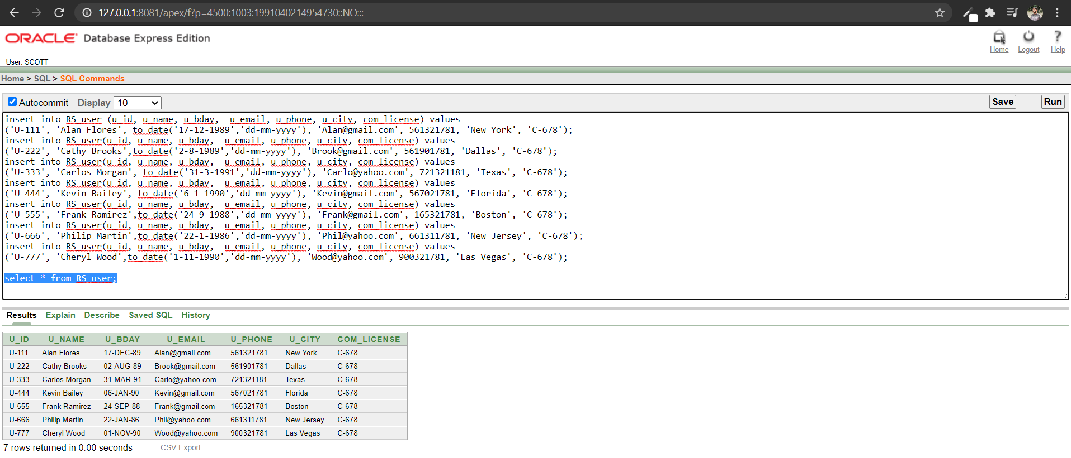

**User_Location**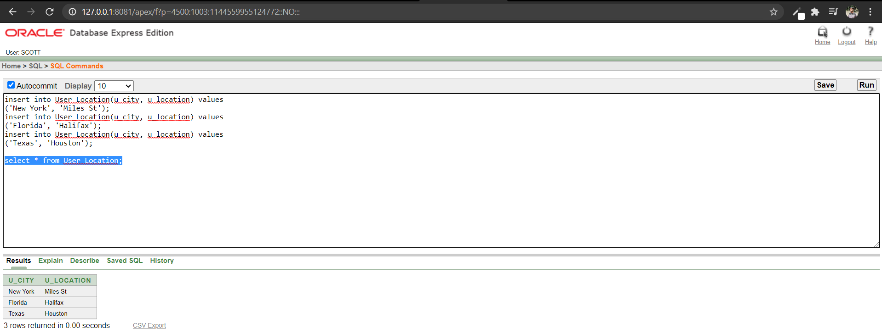

**User_Driver_Rel**

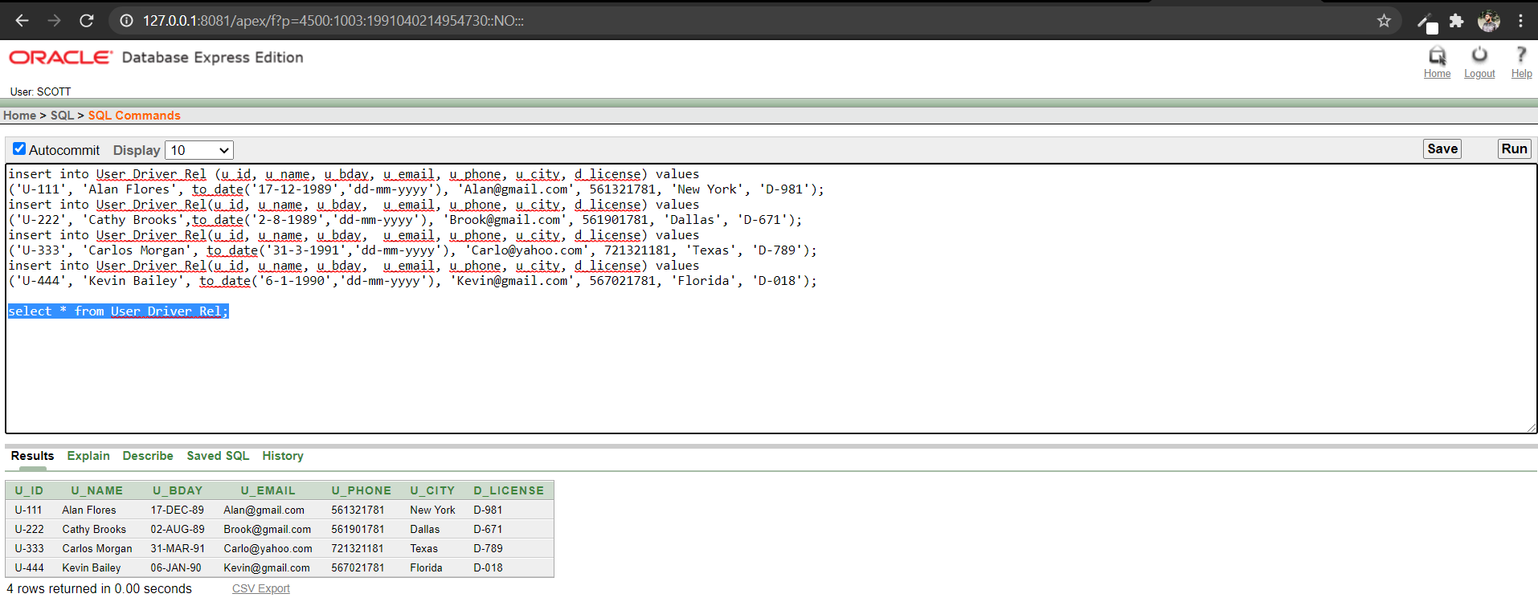

**User_Trip_Rel**

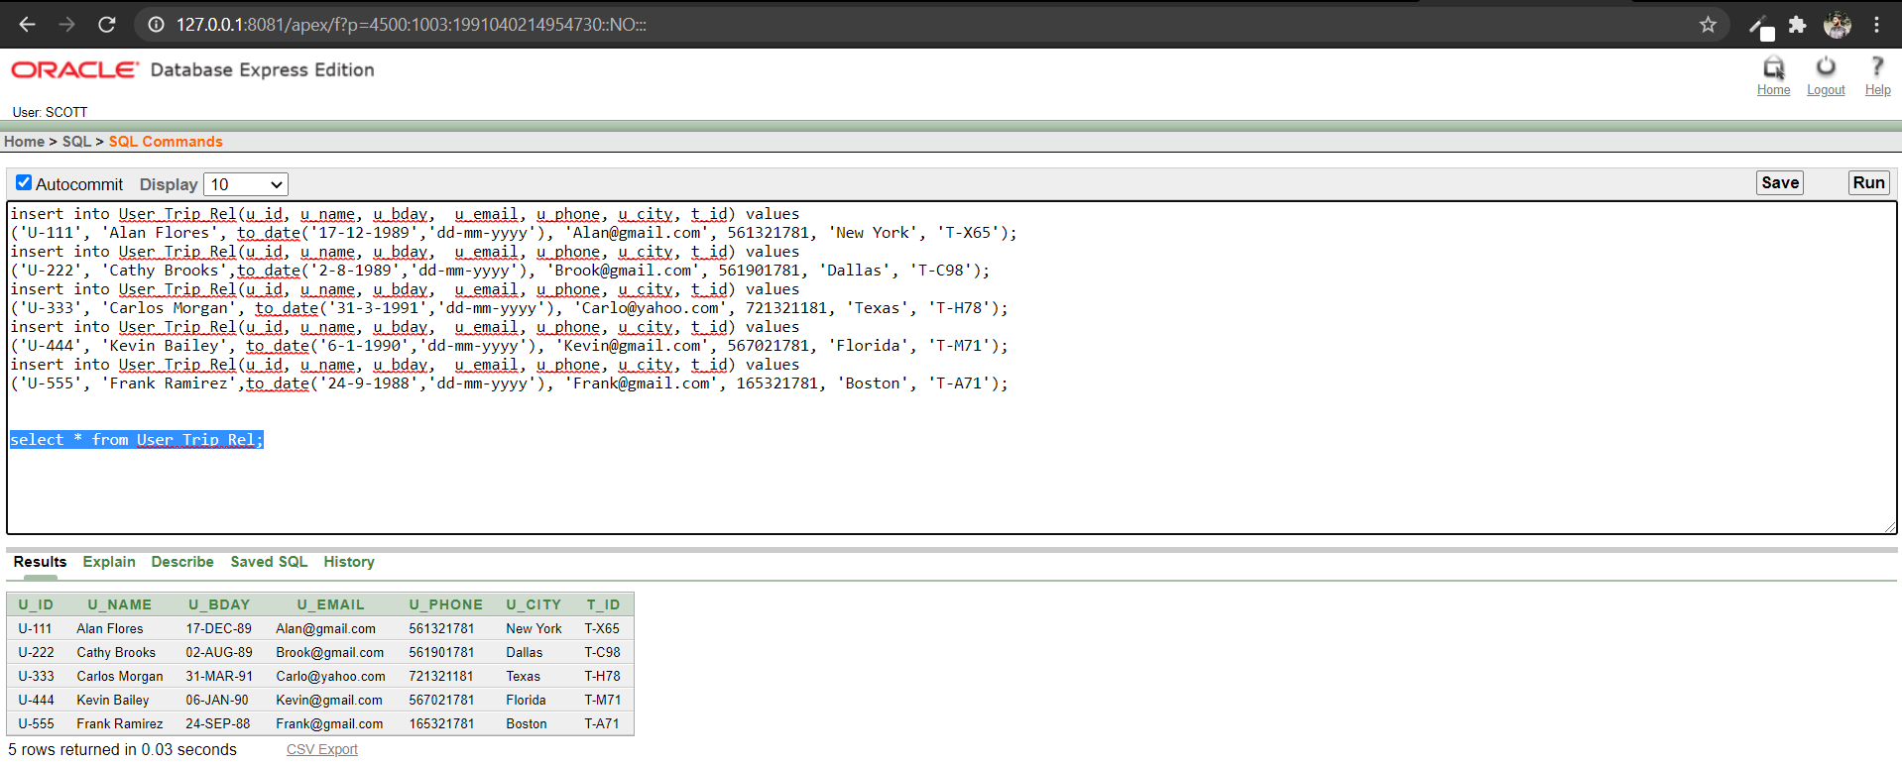

**RS_Driver**

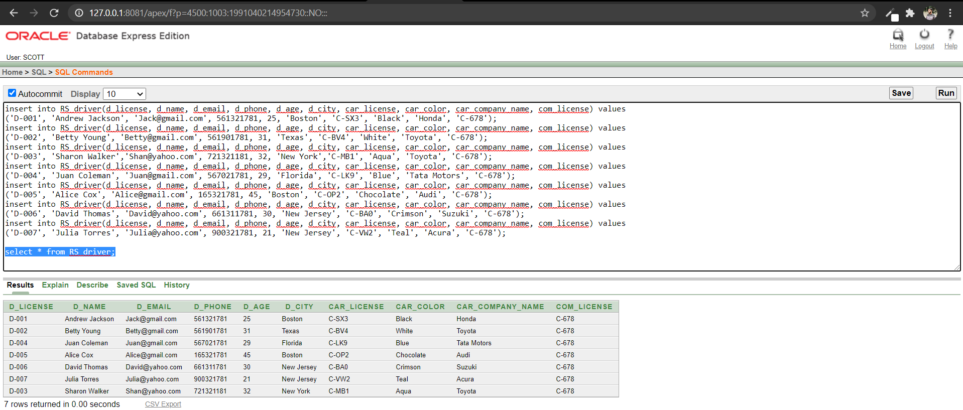

**Driver_Location**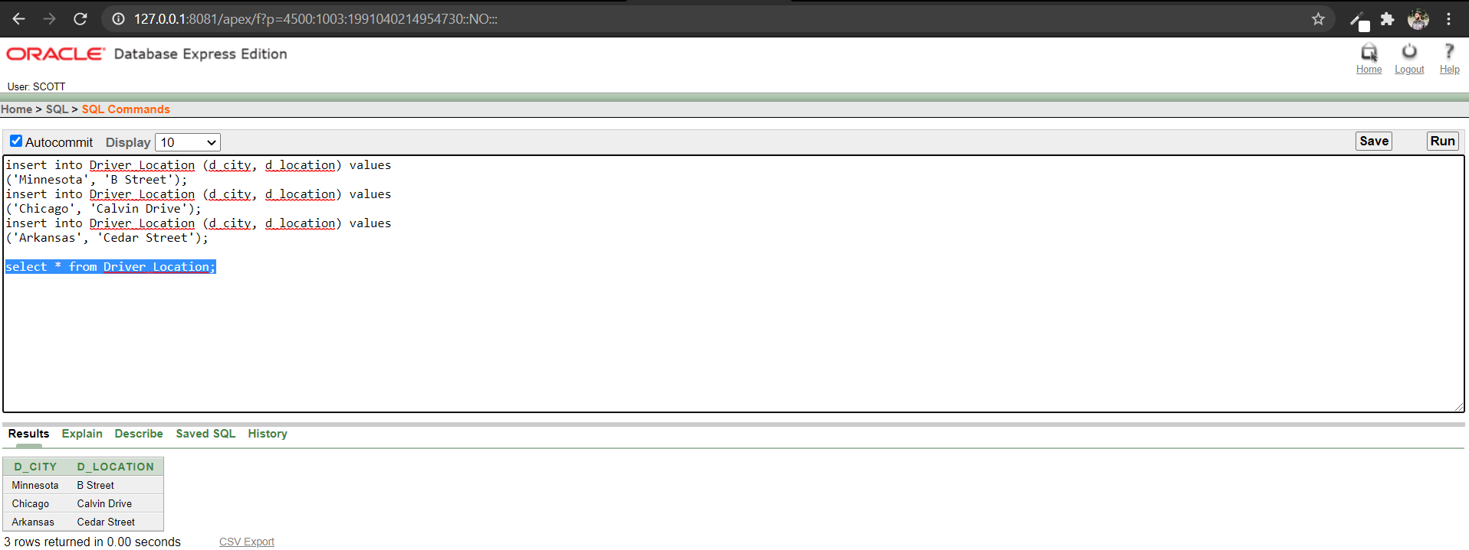

**Driver_Trip_Rel**

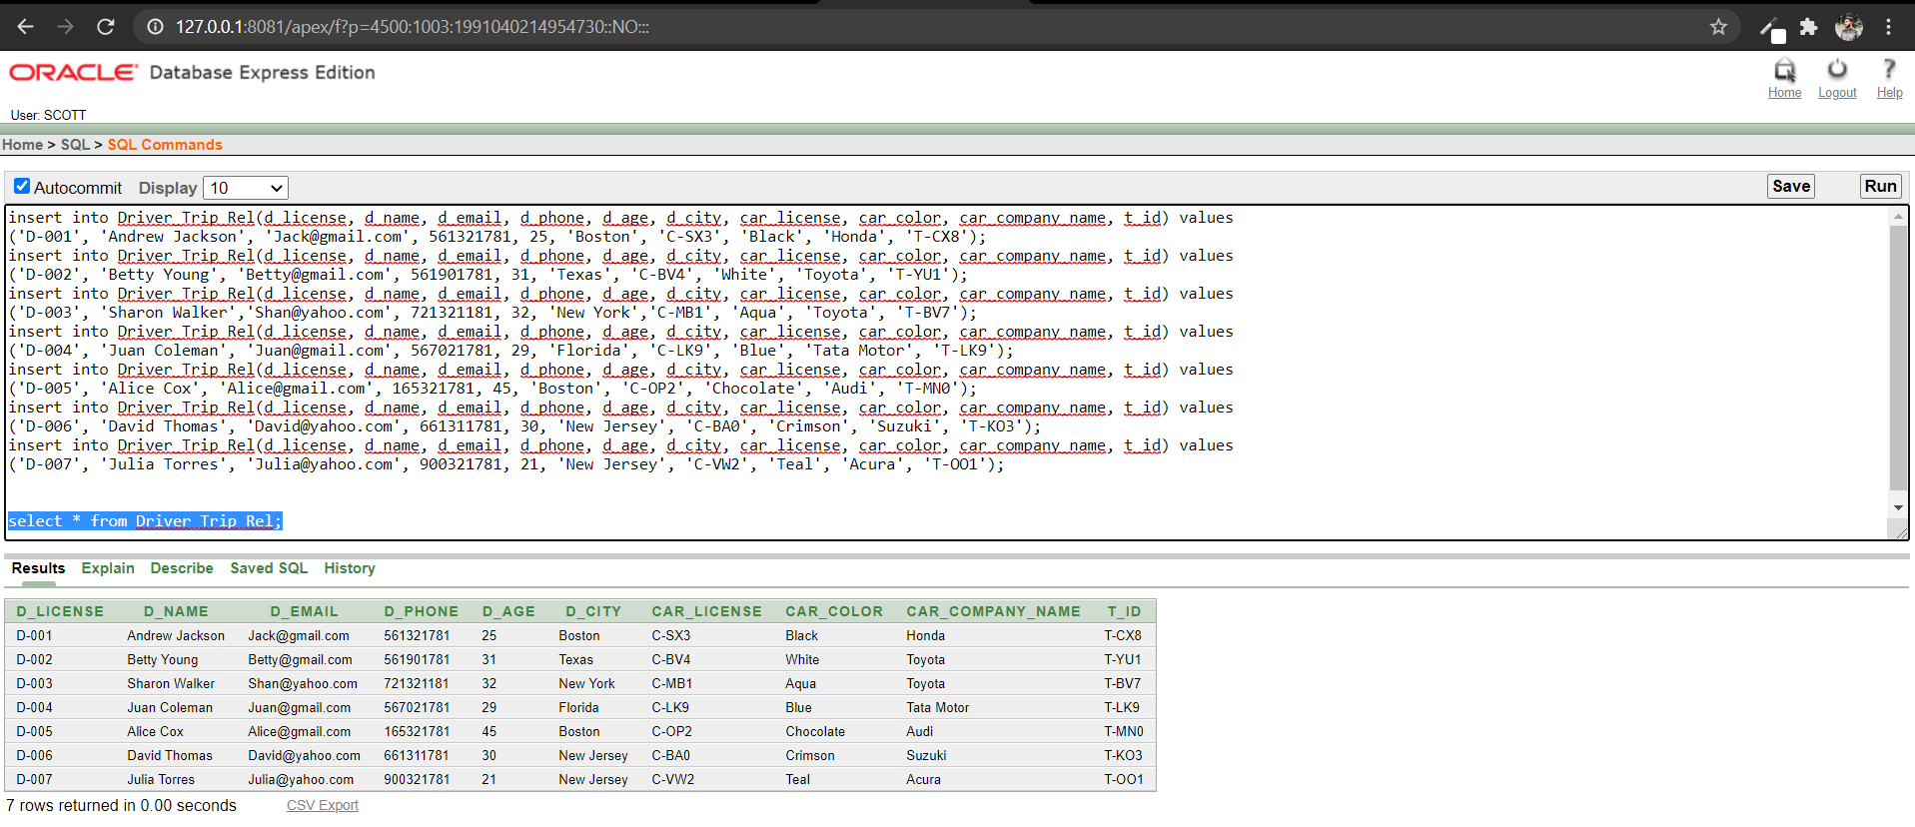

**Car_Details**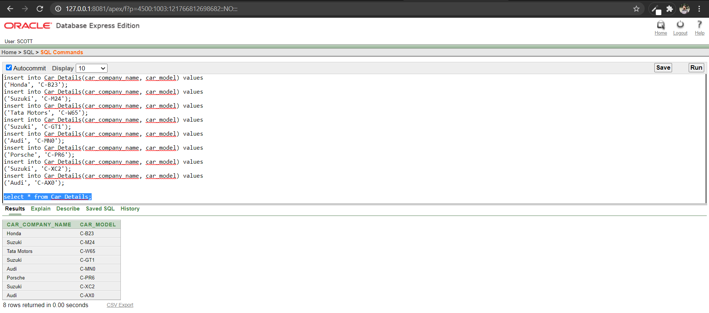

**RS_Trip**

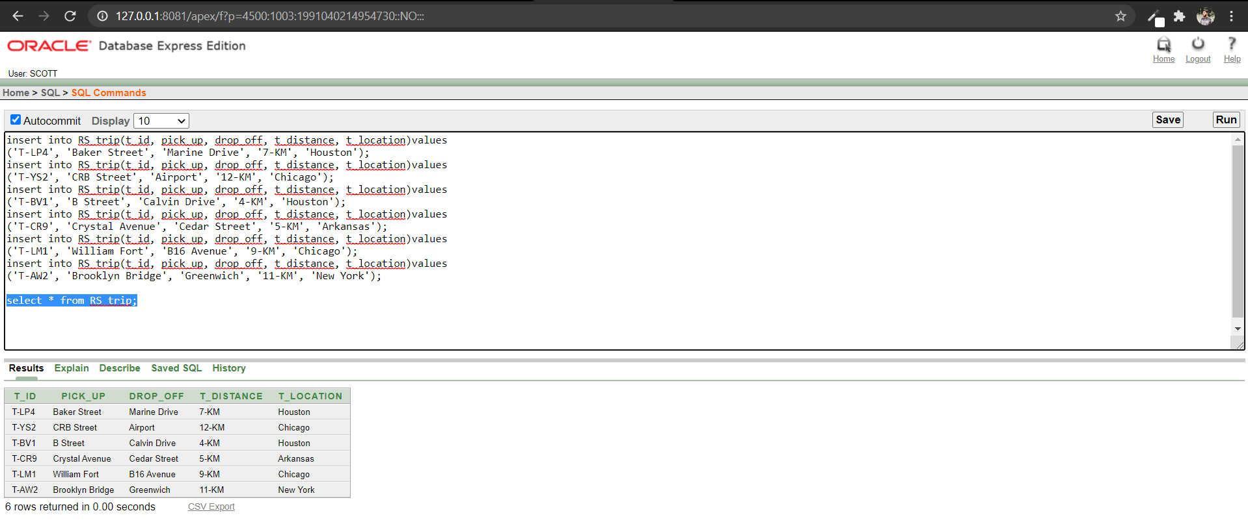

**TripLocation_Cars**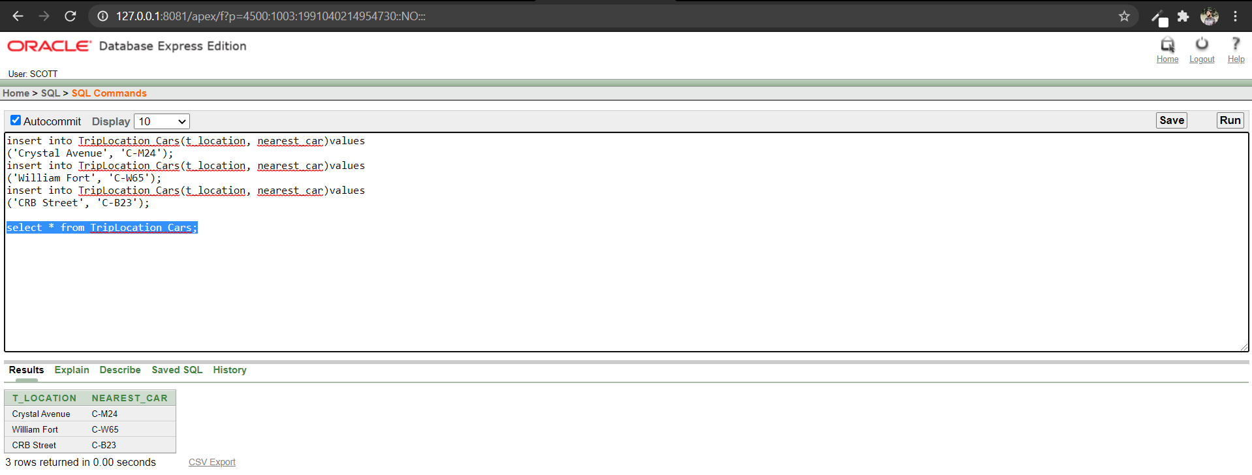

**Query Questions and Answers**

**Display all drivers information whose age is greater than 30 also drives a car of ‘Toyota’ company (Equijoin)**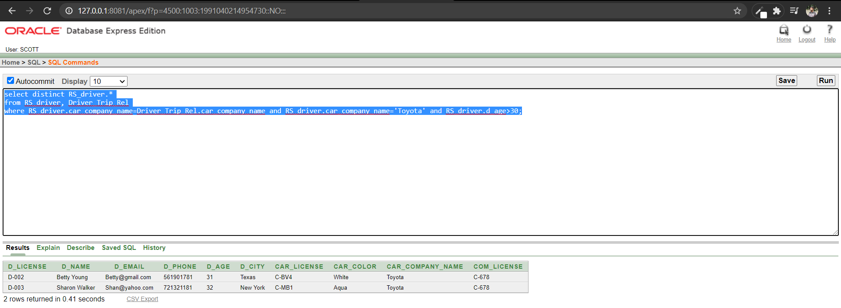

**Display all users information who are located in Texas and New York (Equijoin)**

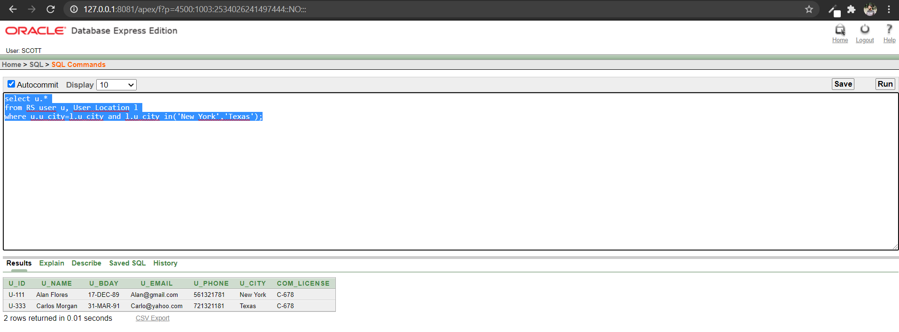

**Display all users name, city and driver information (Outer Join)**

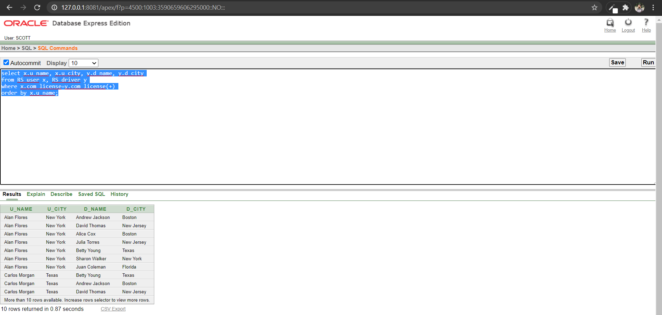

**Display all drivers information who are located in the same city (Self Join)**

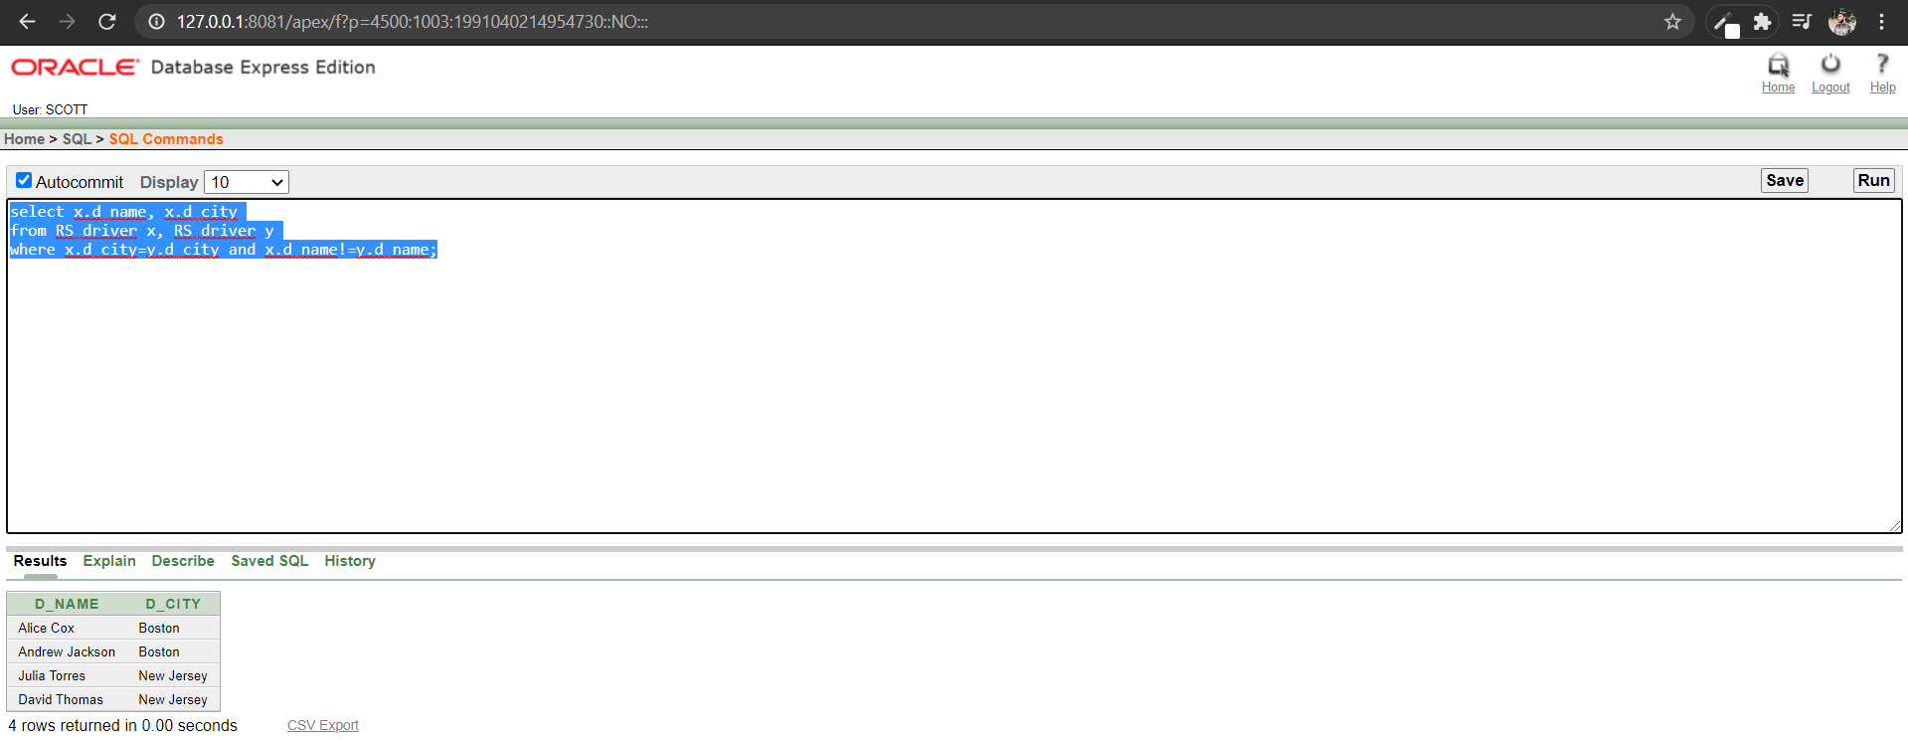

**Display all the nearest cars in ‘CRB Road’ (Sub query)**

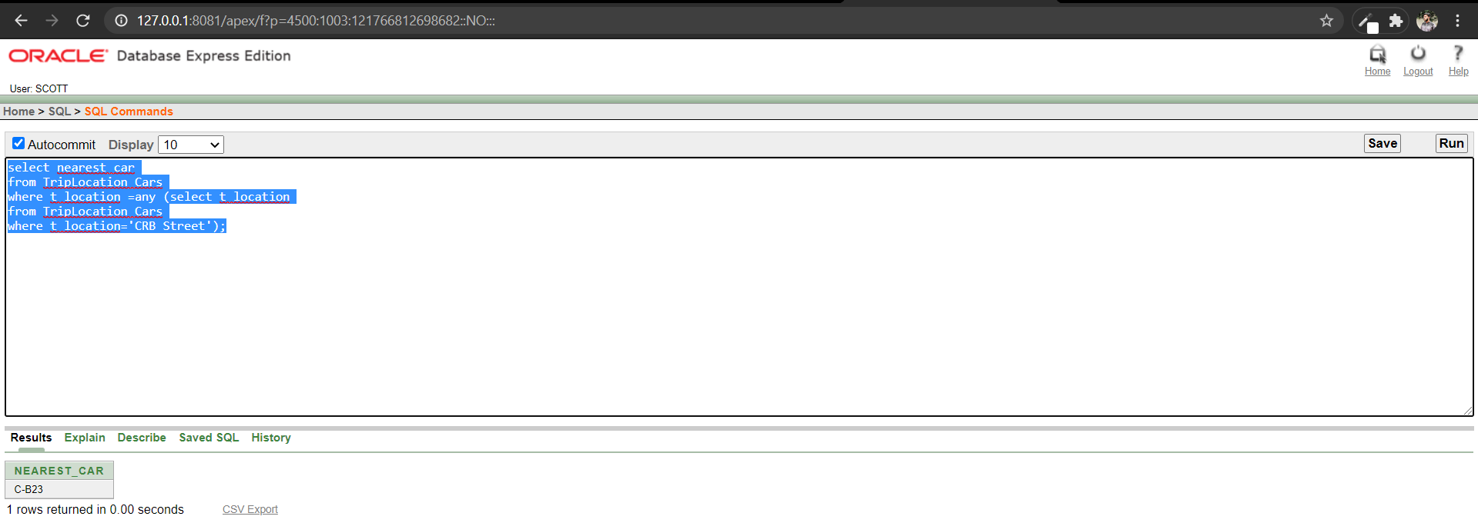

**Display all the cars of ‘Suzuki’ company (Sub query)**

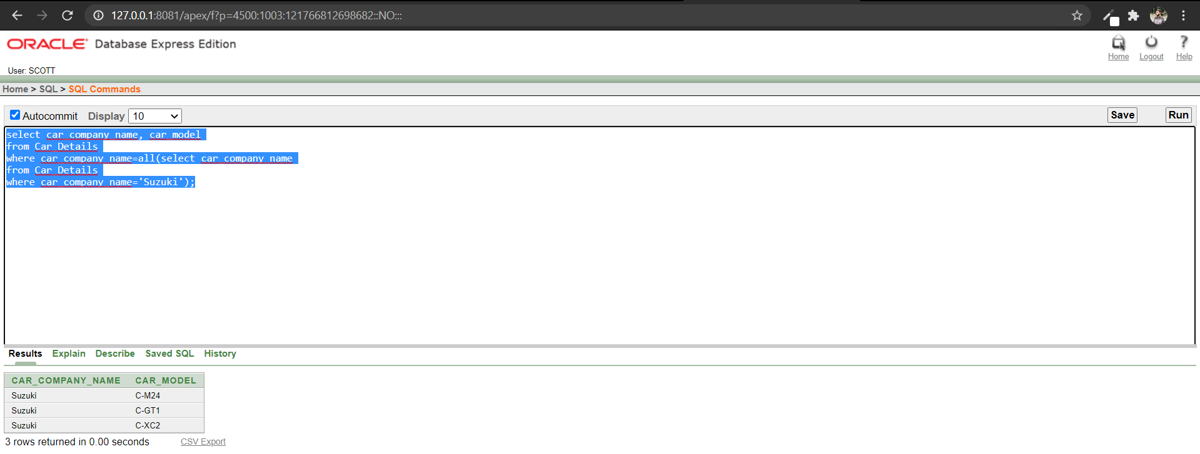

**Display the name, age and phone number of the oldest driver in the company (Sub query)**

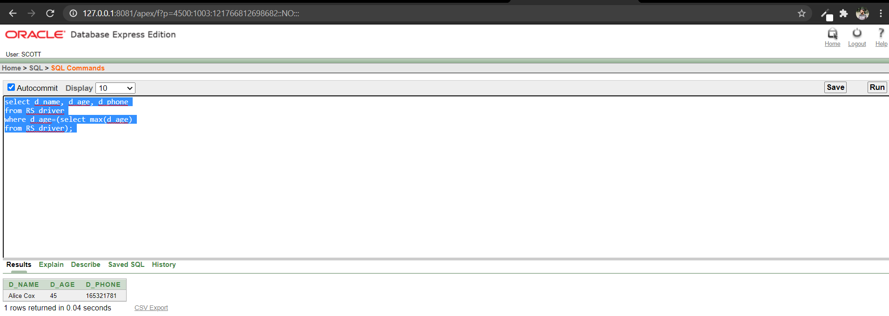

**Display all the information of a user named ‘Kevin Bailey’ (Sub query)**

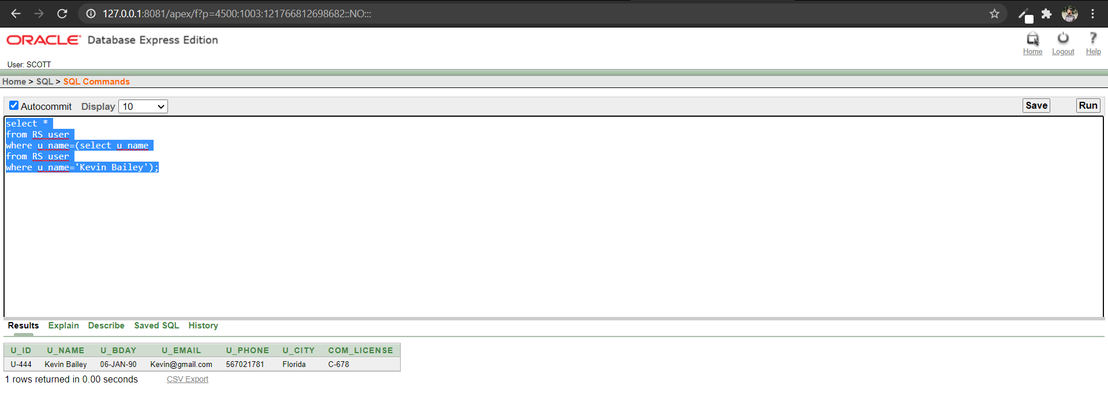

**Create a view (Simple View)**

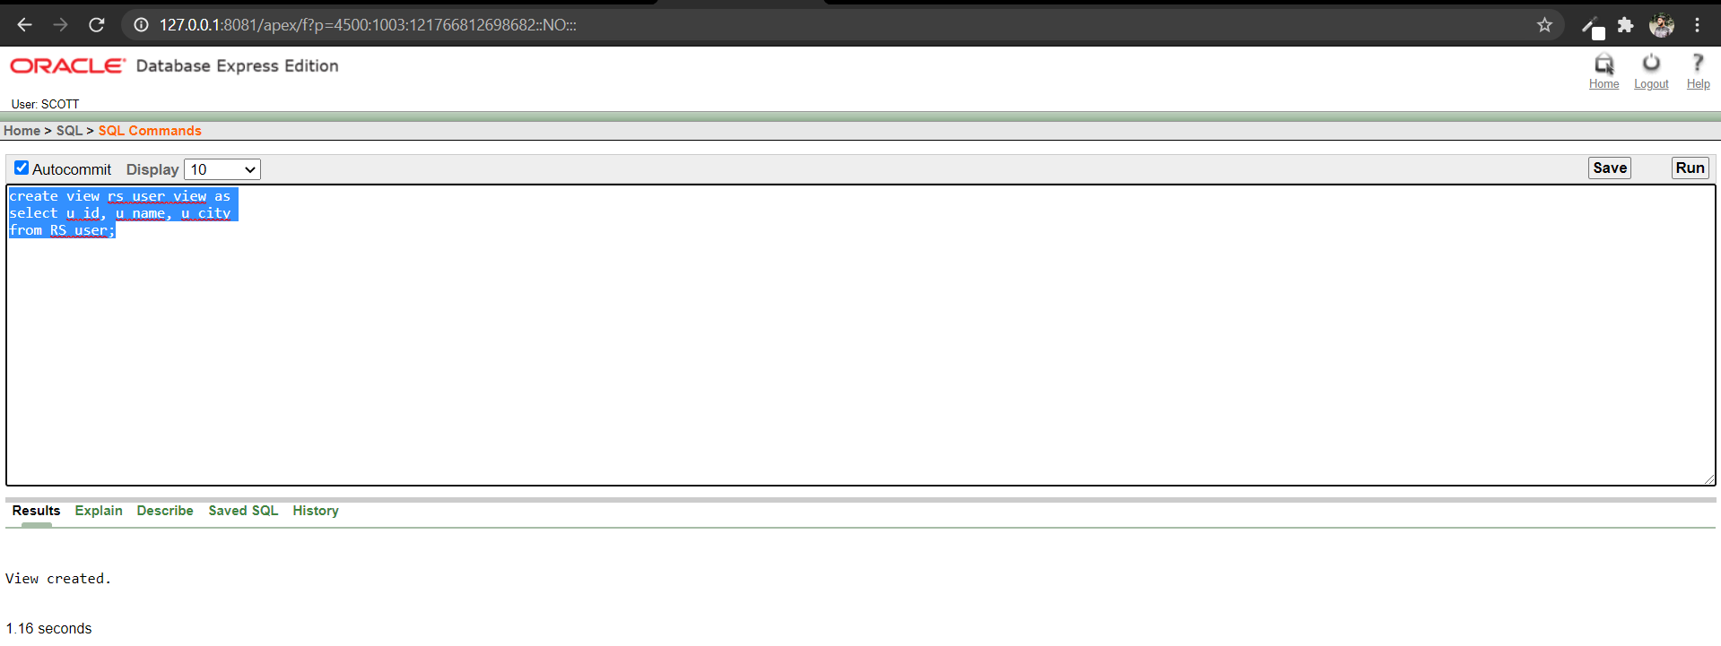

**Create a view (Complex view using joining)**

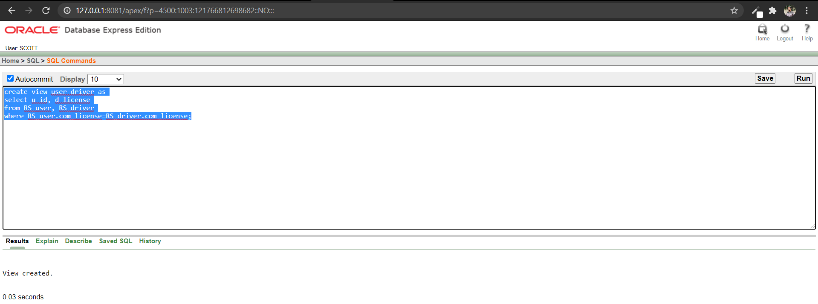

**Add a Constraint**

